Module 10 - Portfolio Exercise: Multiplot it!
Farrell Sevillen Arya
S4270969
27/10/26

Master visualization
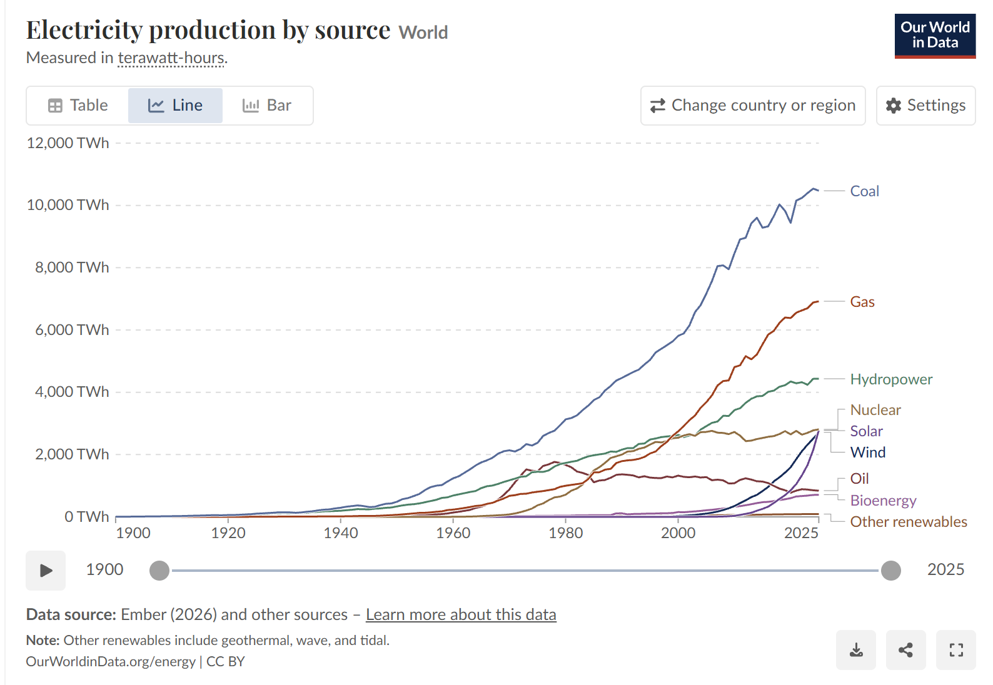
Figure 1. Master Data Visualization: Electricity production by source. Sourced from Our World in Data (2026).

Multiplot Recreation
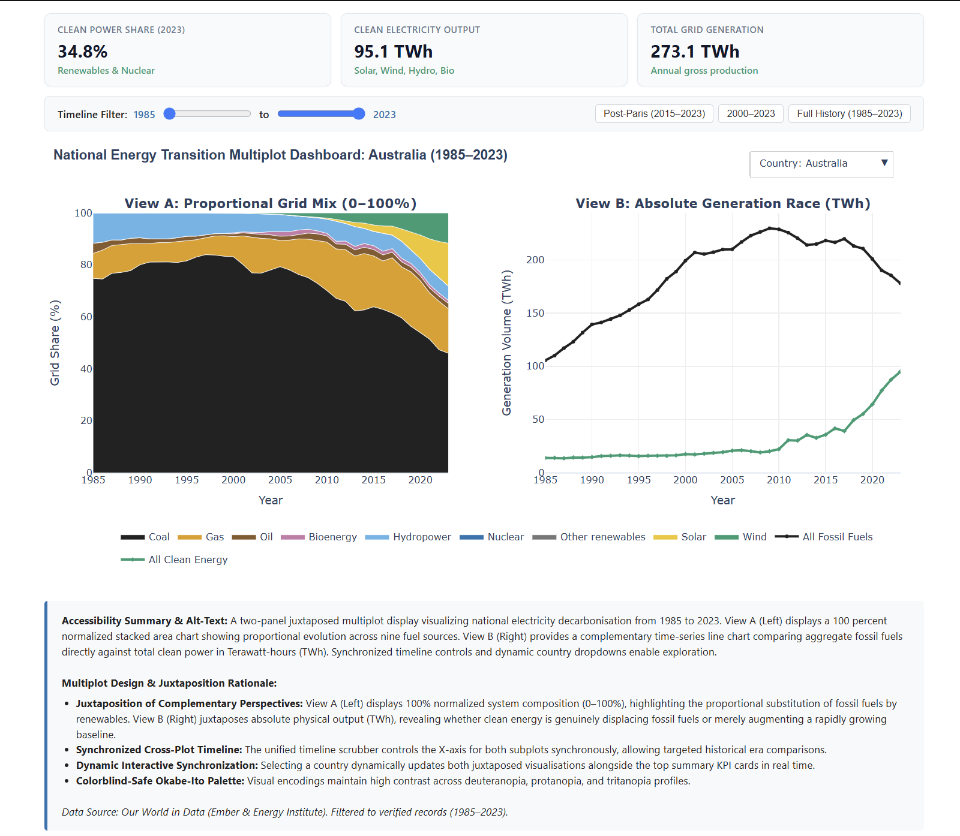
Figure 2. Multiplot dashboard combining a 100% normalized stacked area chart of proportional fuel shares with an aggregate macro volume race (Fossil vs. Clean in TWh), featuring synchronized timeline controls and dynamic country switching using data from Our World in Data (2026).

How I created the multiplot visualization
How I created the multiplot visualization was using the same electricity production by source dataset from Our World in Data (2026) that I used in Module 9. Instead of just displaying individual fuel lines, the goal of this exercise was to combine two complementary views into a side-by-side multiplot display using juxtaposition to reveal insights that a single chart cannot show on its own.

I structured the multiplot into two juxtaposed panels:
1. View A (Left Panel - Proportional Grid Mix): A 100% normalized stacked area chart showing the relative share of all nine fuel technologies (Coal, Gas, Oil, Nuclear, Hydropower, Wind, Solar, Bioenergy, and Other renewables). This shows the structural composition of the power grid and how clean technologies are gradually displacing fossil fuels.
2. View B (Right Panel - Macro Transition Race): A comparative line chart grouping the fuels into two macro categories: Total Fossil Fuels (Coal, Gas, Oil) versus Total Clean Power (Solar, Wind, Hydro, Nuclear, Bioenergy) measured in absolute Terawatt-hours (TWh).

The reason this juxtaposition is useful is that looking at percentages alone can be misleading when total energy consumption is growing. In countries like China or Indonesia, clean power capacity might be expanding rapidly in physical TWh, but because total demand is also surging, the fossil fuel share in View A only declines slowly. In contrast, in economies like Germany, View B clearly reveals the exact historical crossover point where total clean generation physically overtakes fossil fuels.

I also added interactive features to connect the two views. I built a dynamic country dropdown that updates both subplots together across six entities (Australia, Germany, Indonesia, United States, China, and the World). At the top, I added interactive KPI cards that dynamically calculate and display each country's latest clean power share, clean output, and total grid generation. For the time dimension, I built a synchronized timeline scrubber and preset buttons (like Post-Paris 2015 to 2023, and 2000 to 2023) so that dragging the slider zooms both plots simultaneously.

A problem I faced was that when switching countries from Australia to Germany, the bottom legend completely disappeared. This happened because Plotly only showed the legend for Australia's initial traces, and when the dropdown hid Australia, it hid the legend with it. To fix this, I linked all traces to shared legend groups with constant visibility. Another issue was that hovering on one chart produced a massive 10-line tooltip box that blocked the title and axis of the neighboring chart, so I adjusted the hovermode to anchor neatly to individual points.

How I developed the color palette & accessibility
Just like in Module 9, I used the Okabe-Ito colorblind-safe palette (Siegal Lab, n.d.) so the visualizations remain distinguishable for people with deuteranopia, protanopia, and tritanopia. I used the same consistent color mapping across the individual fuel wedges in View A (Charcoal for Coal, Orange for Gas, Umber brown for Oil, Dark Blue for Nuclear, Sky Blue for Hydropower, Green for Wind, Deep Yellow for Solar, Purple for Bioenergy, and Grey for Other renewables). For View B, I used high-contrast styling with Dark Charcoal for Fossil Fuels and Vibrant Green with diamond markers for Clean Power. I also added thin white separation lines between the stacked area wedges so the colors don't bleed into each other, and added alt-text and structured captions.

Data Card
Parameter | Attribute Details
Title | National Energy Transition Multiplot Dashboard (1985–2023)
Summary | A two-panel juxtaposed multiplot visualization comparing proportional grid composition (100% normalized stacked area) against aggregate physical generation trajectories (fossil vs. clean in TWh) from 1985 to 2023 across six economies: Australia, Germany, Indonesia, United States, China, and the World.
Data Sources | Primary Source / Host: Our World in Data. (2026). Electricity Production by Source [Data set]. Our World in Data  Original Source 1: Ember. (2026). Yearly Electricity Data [Data set]. Ember Climate  Original Source 2: Energy Institute. (2026). Statistical Review of World Energy [Data set]. Energy Institute
Mapping | X axis: Year, continuous annual time steps from 1985 to 2023 synchronized across both subplots (OWID / Ember / Energy Institute, 2026).  Y axis (View A): Grid Share (%) — normalized proportion of each fuel source relative to gross annual electricity generation, ranging from 0% to 100% (OWID / Ember / Energy Institute, 2026).  Y axis (View B): Generation Volume (TWh) — aggregate physical electricity production comparing Total Fossil Fuels (Coal, Gas, Oil) against Total Clean Energy (Solar, Wind, Hydro, Nuclear, Bioenergy) (OWID / Ember / Energy Institute, 2026).
Important Notes | Preprocessing and Filtering: Sourced from Our World in Data global records. Filtered to 1985–2023 to maintain consistent technology reporting. Nine fuel sources were aggregated into two macro sums (Total Fossil and Total Clean Power). Percentages were calculated for each fuel to generate 100% stacked areas. Six key representative entities were selected.  Missing Data: Null values were filled with 0. Preliminary records for 2024–2025 were excluded due to reporting lag in developing nations.
Access | Direct page access to download data: https://ourworldindata.org/grapher/electricity-production-by-source?overlay=download-data

References
Ember. (2026). Yearly electricity data [Data set]. https://ember-climate.org/data/data-tools/data-explorer/

Energy Institute. (2026). Statistical review of world energy [Data set]. https://www.energyinst.org/statistical-review

Our World in Data. (2026). Electricity production by source [Data visualization and data set]. Global Change Data Lab. https://ourworldindata.org/grapher/electricity-production-by-source

Siegal Lab. (n.d.). Color palette. Department of Biology and Center for Genomics & Systems Biology, New York University. https://siegal.bio.nyu.edu/color-palette/

